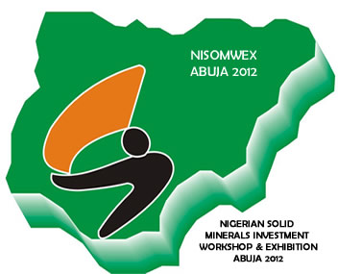
NISOMWEX 2012
NIGERIAN SOLID MINERALS INVESTMENT WORKSHOP & EXHIBITION 2012
May 17-18, 2012 – NICON LUXURY HOTEL ABUJA, NIGERIA.
Registration /Booking Form
(Additional copies may be made)

Please complete this form in Block Capital Letters

Name (as it appears on your passport) ……………………………………:……..…………………………………..………………..

Organisation: …………………………………………………………………………………………………………………………………………

Address…………………………………………………………..…………………………………………………………………..…………………

Telephone No………………............................................................... Fax :……………………………………………….......

Email:………………………………………………………………………….Position………………………………………………………………

Occupation ……………………………………………………..……………………………………………………………………………………….

Nominating Officer:………………………………………………………………………………………………………………………………..

Attendance Fee: N50,000.00 ($320.00) per person.

Please, make cheques payable to Dredge Skills and Marine Training Centre Ltd OR By Bank payment to the following Account:
Nigerian Naira Account – GT Bank Plc, Account No: 227-647203-9110.

For Dollar payments in our Domiciliary Account please email us for an invoice.

SIGNATURE:…………………………………………………………………..…… DATE:……………………………..……………………………....

This form should be sent to the Summit Secretariat ,Dredge Skills and Marine Training Centre Ltd, Cheryn’s Place, 2nd Floor, Ikota First Gate, Near VGC, Aja, Lagos Nigeria.
Email: dredgeskills@gmail.com
Tel: + 234 1 7928166; +234 (0)803 337 8735

