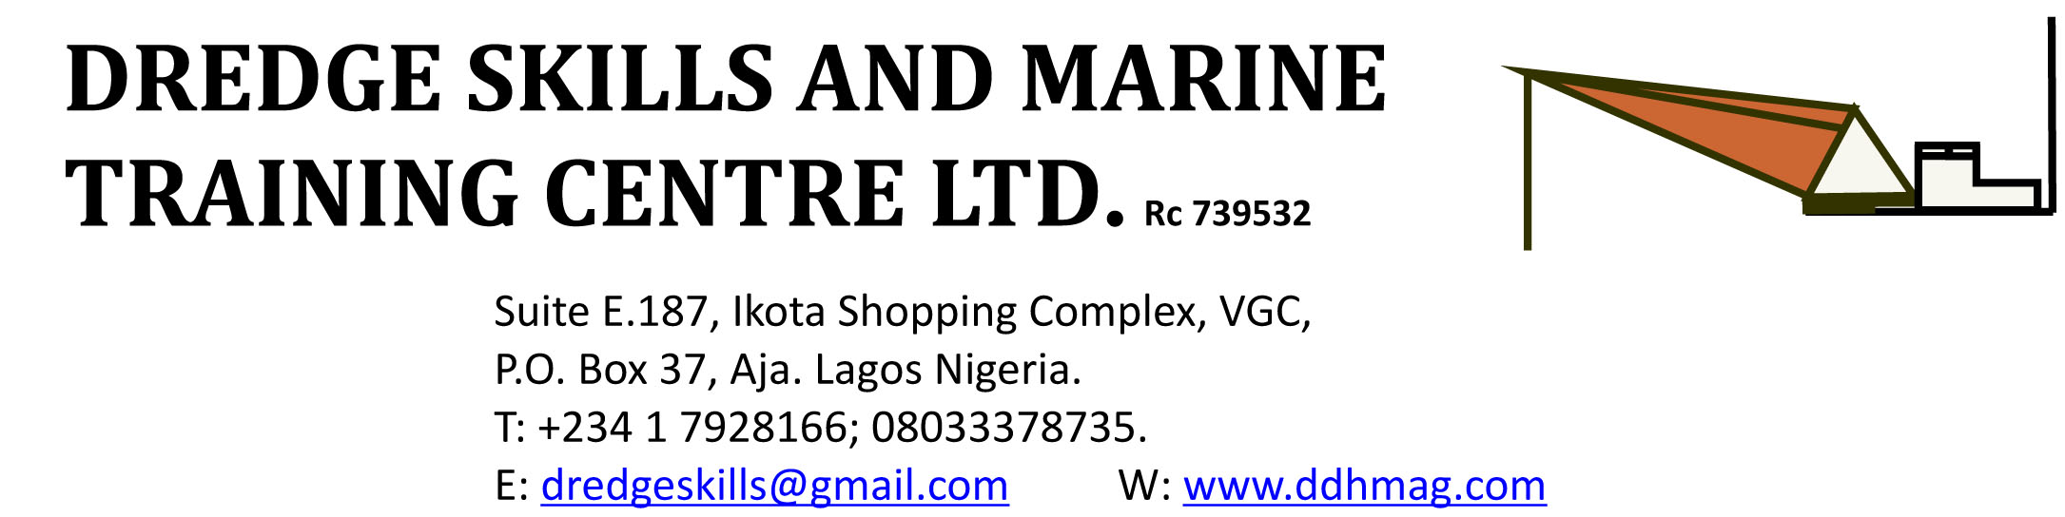

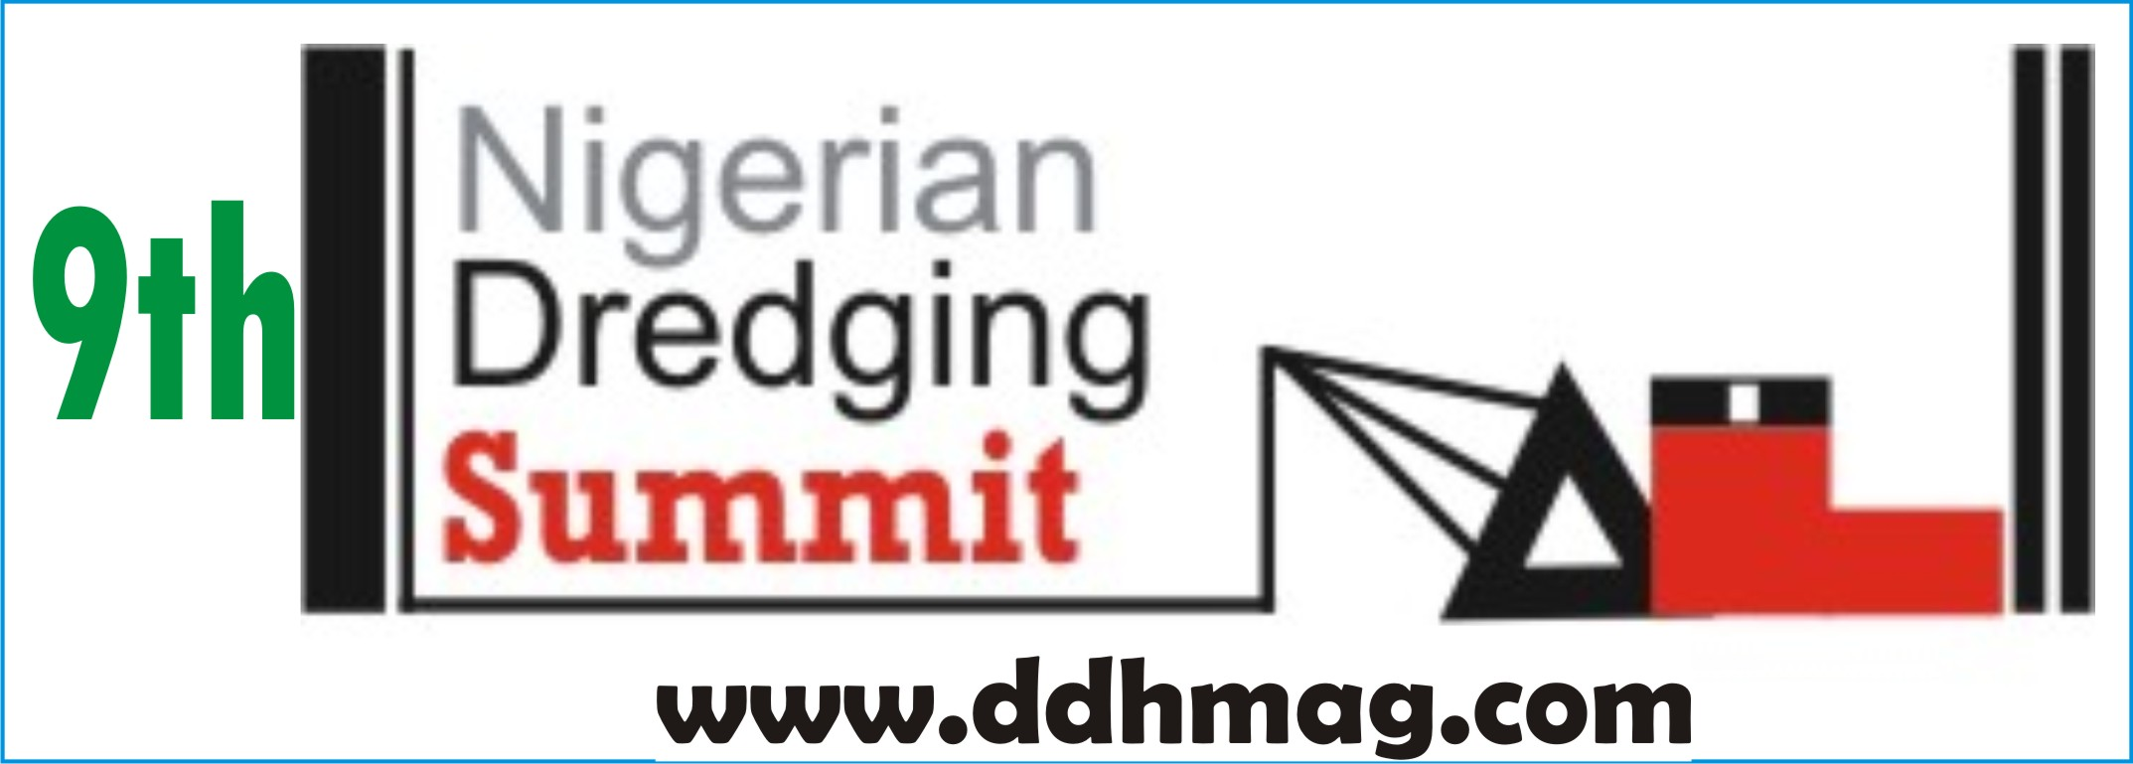
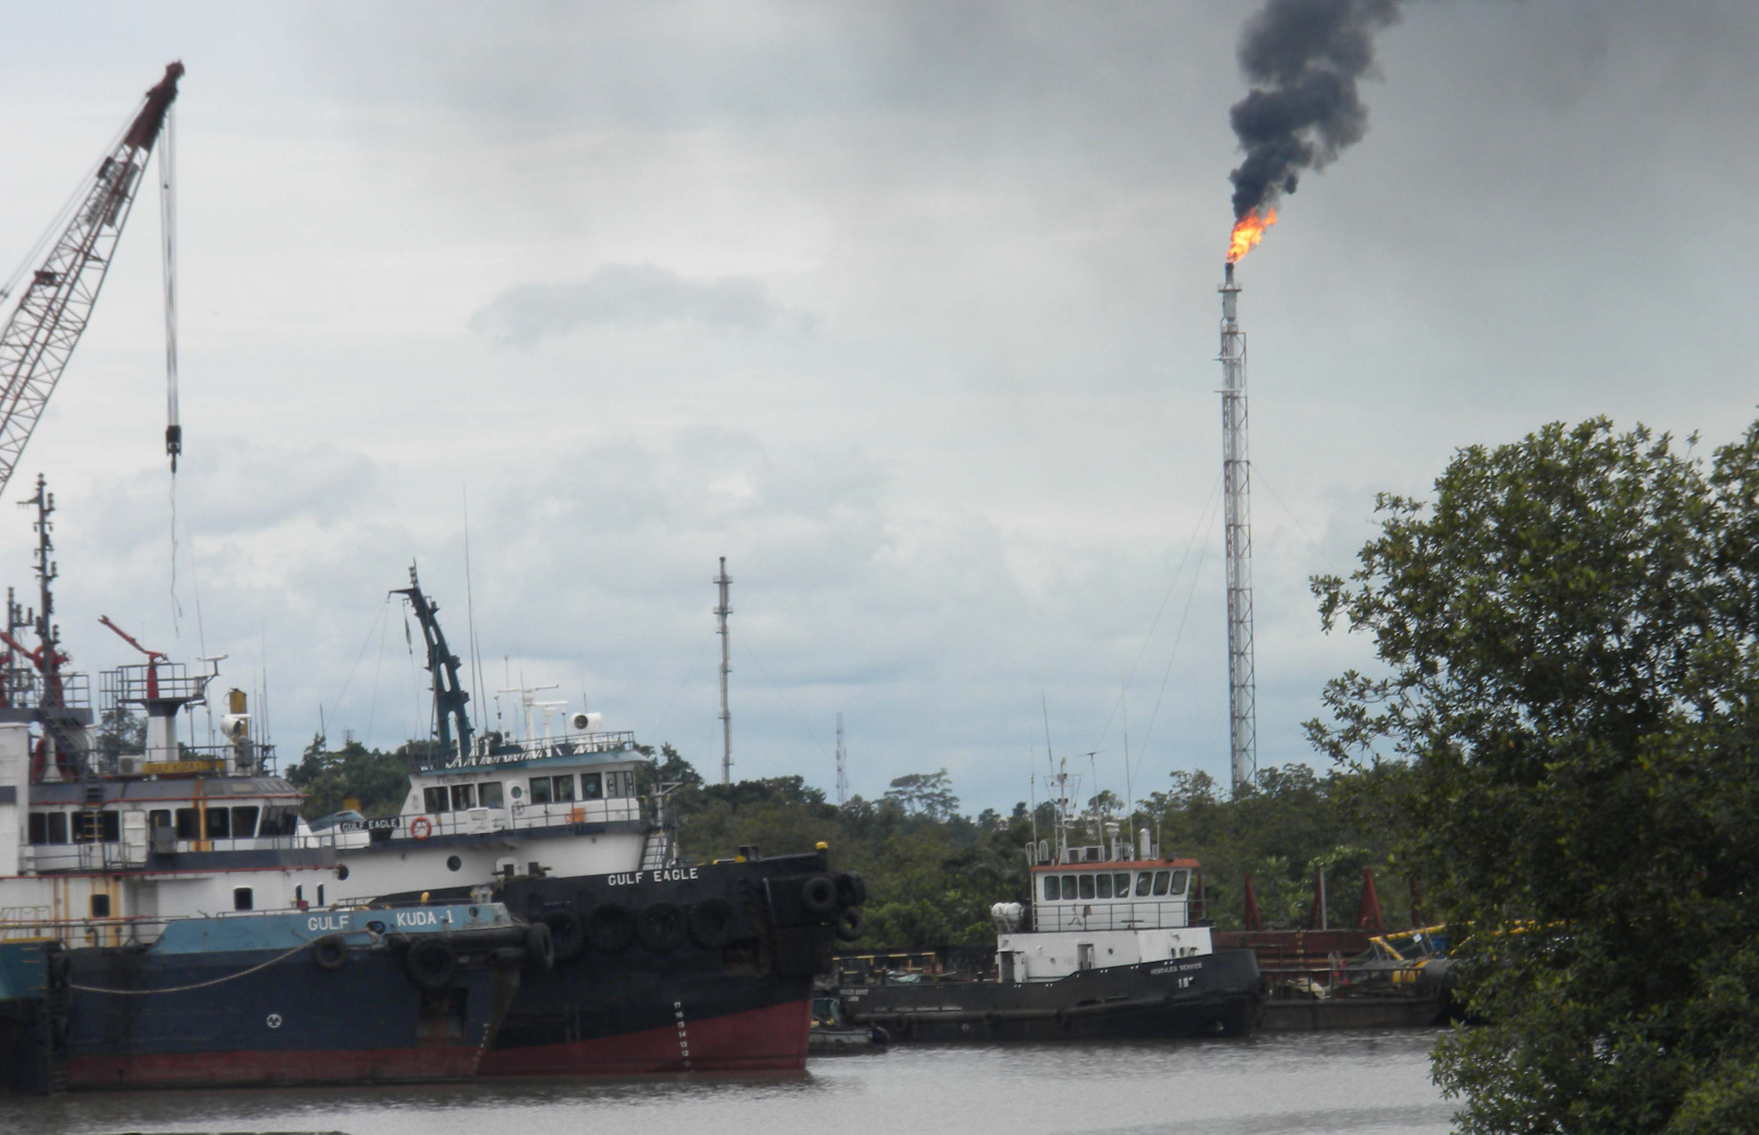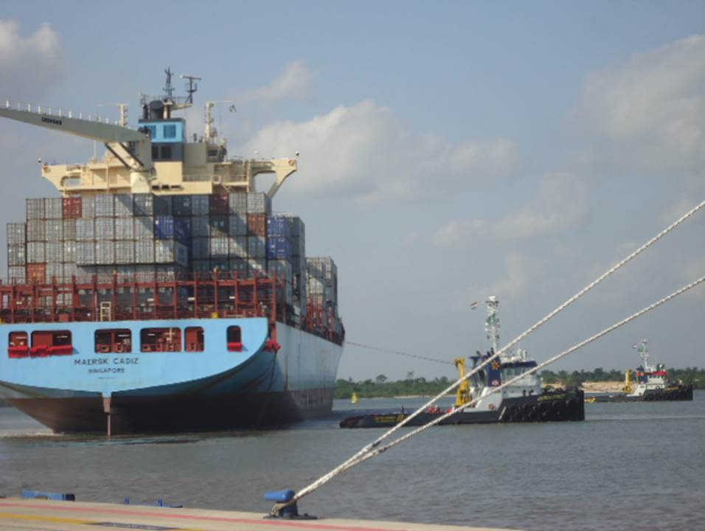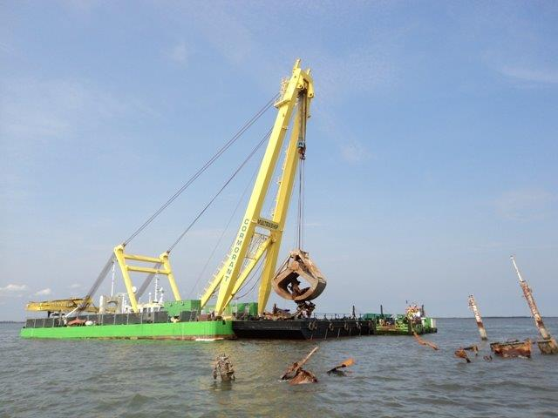

9TH NIGERIAN DREDGING SUMMIT AND EXHIBITION
Port Harcourt Garden City 2015
With SEMINARS, Exhibitions & EXCURSIONS to TOURIST ATTRACTIONS
INVITATION TO NOMINATE DELEGATES

THEME: DREDGING SOLUTIONS FOR NAVIGATION CHANNELS, CARGO MANAGEMENT AND THE ENVIRONMENT
You are hereby invited to nominate delegates and exhibit at the 9th edition of the Nigerian Dredging Summit and Exhibition which will take place as follows:
Date: Wednesday to Friday, October 14-16, 2015.
Venue: Beverly Hills Hotel, Port Harcourt.
Time: 9:00am.
Brief Introduction
Since 2007, the annual Nigerian dredging summit has offered a supportive forum for operators and stakeholders from within and outside Nigeria to meet and share ideas on the burning issues in the industry. Dredge manufacturers, equipment vendors and service providers have found it a marketplace for their wares and the exhibition stands have made many connections that boosted successful business.

Dredging activities, especially sand winning and reclamation, are fast assuming predominant positions as the solutions of choice for the building, real estate, construction and sand-filling subsectors. The increased demand for all grades of sand is only a part of the dredging industry’s scope whose services also cover most shore-based and shallow-water oilfield production in Nigeria. Thus, indigenous dredging contractors require the right training, orientation or re-orientation for providing adequate products and services for these sectors.

As an index of interest in the programme, the number and variety of participants in the annual summit and exhibitions continue to increase, comprising Nigerian and foreign dredging companies, equipment manufacturers, suppliers and vendors, federal and state government ministries and regulatory agencies. Regular participants include Ministry of Mines and Steel, Ministry of Environment, Ministry of Petroleum, Ministry of Transport, NNPC, NPA, NIMASA, NCDMB, LCM, BCC, Maritime Academy of Nigeria, Ministry of Works, Ministry of Water Resources, etc.
The theme of this year’s event is Dredging Solutions for Navigation Channels, Cargo Management and the Environment and the programme will address emergent issues such as the situation along the Bonny River channel where its contours have to be trained to accommodate bigger vessels or the situation further downstream at Onne Port where such bigger vessels’ requirements for movements around the port and cargo handling have to be met by extra engineering works. This was a major achievement of one of the joint venture channel management companies and, added to expansion works at the Lagos channel and the commencement of the Calabar channel management company, would form the kernel of most of the seminar papers and presentations at the 2015 event.
EXCURSION
As usual, there will be excursions to dredging sites and other places of interest. Delegates are usually conveyed in air-conditioned buses on the second day of the summit and exhibition. This year, the excursions include provisional arrangements to visit some dredging sites deep along the Bonny channel using air-conditioned boats. Lunch shall be served on-the-go and the entire package comes as part of the participation fee and does not require any extra payment. Delegates are advised to come with running shoes or sneakers to better enjoy the experience. T-shirts and caps will be freely supplied.

LEADING PAPERS AND PRESENTATIONS AT THE SUMMIT:
- “EIA Regimes and Environmentally-Safe Dredging Techniques: The Critical Benchmarks” by Federal Ministry of Environment / Dr. T. Ndoho.
- “Opportunities for Dredging and Sand Mining in the Niger Delta” by River State Ministry of Environment.
- Buying or Leasing Dredgers – Options for Importation or Building in-country. By Engr Sunday Otuya.
- Training Options for Dredging and Marine Skills. University of Uyo (Capt. Ntiandem)
- Financing Dredge Sector Equipment and Leasing in Nigeria by a Bank.
- Challenges of Megacity Drainage Systems: The Case of Lagos by Lagos State Ministry of Environment.
- “The Future of Port Development in Nigeria” by Nigerian Ports Authority.
- “Dredging the Lagos Seaports System for Expansion in Cargo Handling by Lagos Channel Management.
- “The Future of Port Harcourt Port and Expansion of Shipping along the Bonny Channel” by Bonny Channel Company.
- “Developing the Calabar Channel for Bigger Ships” by Calabar Channel Management.
- “The National Framework for Intermodal Transportation” by Federal Ministry of Transport.
- “Dredge and Equipment Repairs, Maintenance and Inspection” by Dave Moore / Engr Sunday Otuya.
- “Implementing Cabotage Law for Dredging Activities: Deepening NIMASA’s Role in Harbour Dredging and Sand Mining.”
- Pre-Dredge Surveys and Proofing Sand Search Reports. By Osanebi Felix.

EXHIBITION STANDS /MARKETING
As usual, the organizers encourage equipment vendors and other service providers to show off their wares or services on the sidelines of the dredging summit. Organizations that are interested in taking up Exhibition spaces should contact the organizers as soon as possible via email or telephone. See the section on participation fees below for costs and size of booths.

REASONS FOR THE SUMMIT AND EXHIBITION
- Dredging activities are now becoming a solution of choice for many projects of the federal, state and local governments. It has always served the needs of oil field operating companies. In recent times, many startup Nigerian firms have joined the ranks of foreign dredging contractors, so that dredging in Nigeria today has come to stay and is now widening in scope, thus the need for constant information to stakeholders and operators.
- To nurture the growing Nigerian industry, there is an increasing need for best practices to be instituted as a guide for all stakeholders. Especially for new entrants into the sector, there is the need for dissemination of adequate knowledge and information about rules and regulations and technical know-how to improve the industry from time to time.
- The Nigerian Dredging Summit is also a marketing arena, a meeting place for dredging and dredge equipment makers and vendors as well as a place for interaction between environmental engineers, consultants, academics and governmental regulatory agencies for the exchange of ideas and meaningful debates of existing policies.
- The summit provides another forum of a meeting for umbrella associations in the dredging sector.

BENEFITS OF ATTENDING…

- Local and international exposure for participants.
- For some attendants, it is an opportunity to visit new places and locations they only read about in the mass media and to relieve stress for busy operators.
- Up to 10 or more staff of each participating organization can be accommodated to experience the interaction, exposure and training that comes with the event.
- Staff morale is usually boosted by involving them in this event and they return to their desks more motivated and enlightened to deliver quality service and performance at their jobs.
- Each participating organization will have the option of addressing the delegates on the various statutory mandates of their establishments and new developments and thus promote the implementation of government or company policies needed to achieve governmental budgetary or corporate aspirations. Companies get an opportunity for sales talk via Powerpoint presentations.
- Board members of participating agencies or organizations may attend to keep abreast of relevant issues.
- Interaction with professionals in the dredging sector yields future collaboration and networking between public and private sector operators in various areas of the economy.

PARTICIPATION FEES.
REGISTRATION FEES:
Individual Delegate (1 person) N100,000.00
Group Delegates, 3 participants N260,000.00
Group Delegates, 4 participants N340,000.00
Group Delegates, 5 participants N400,000.00

CORPORATE PARTICIPATION PACKAGES
OPTION A:
- 12 or more delegates.
- A Stand at the Exhibition Hall for interactions with participants interested in your organization.
- Display of podium or hallway banner adverts at the venue.
- 1 full-page colour advert or public notice of the organization in the Nigerian Dredging Summit Brochure.
- 1 full page of the Dredging Summit Brochure devoted to a corporate profile of the organization with pictures of their management staff.
- To be listed as an official sponsor in any radio, television or print advert of the Summit prior to the event.
COST - N6m
Option B
- 8 Delegates.
- A Stand at the Exhibition Hall for interactions with participants interested in your organization.
- Display of a hallway banner advert at the venue.
- 1 half-page colour advert or public notice of the organization in the Nigerian Dredging Summit Brochure.
- 1 half-page of the Dredging Summit Brochure devoted to a corporate profile of the organization with pictures of their management staff.
- To be listed as an official sponsor in any radio, television or print advert of the Summit prior to the event.
COST - N4.5m.
Option C
- 6 Delegates.
- A Stand at the Exhibition Hall for interactions with participants interested in your organization.
- Display of a hallway banner advert at the venue.
- 1 quarter-page colour advert or public notice of the organization in the Nigerian Dredging Summit Brochure.
- 1 quarter-page of the Dredging Summit Brochure devoted to a corporate profile of the organization with pictures of their management staff.
- To be listed as an official sponsor in any radio, television or print advert of the Summit prior to the event.
COST – N3m .
Option D
- 3 Delegates.
- 1 quarter-page Black-and-White advert or public notice of the organization in the Nigerian Dredging Summit Brochure.
- To be listed as an official sponsor in any radio, television or print advert of the Summit prior to the event.
COST – N1.5m

Cost of Booth: N250,000.00 per booth (measuring 3m x 3m, 9sq m.)
(If more booth space is needed, please let us know and we shall revert immediately.)

SUMMIT COLOUR BROCHURE
A Summit Colour Brochure where adverts can be placed is usually published for the Event with the following advert rates.
Advertisement rates for the Colour Brochure:
Outside Back Cover N250,000.00
Inside Front Page N200,000.00
Inside Back Cover N180,000.00
Full page N150,000.00
Half Page N95,000.00
MODE OF PAYMENT
Two modes of payment are acceptable.
- By cheque, made payable to: DREDGE SKILLS AND MARINE TRAINING CENTRE LTD.

- Or by bank transfer / E-Payment to our bank accounts as follows:

Name of Bank: GT Bank Plc, Ajah Branch.
Name of Account: Dredge Skills And Marine Training Centre Ltd.
Account Number: 0013355857.
Sort Code: 058152272.
Email Address: dredgeskills@gmail.com
Telephone: 08033378735.
To request payment invoices, please contact the secretariat by email or phone.
CONTACT DETAILS
Dredge Skills And Marine Training Centre Ltd,
E270 Ikota Shopping Complex,
VGC AJAH.
LAGOS.
Telephone: +234 1 7928166 or 08033378735.
Email: dredgeskills@gmail.com
Website: www.ddhmag.com

