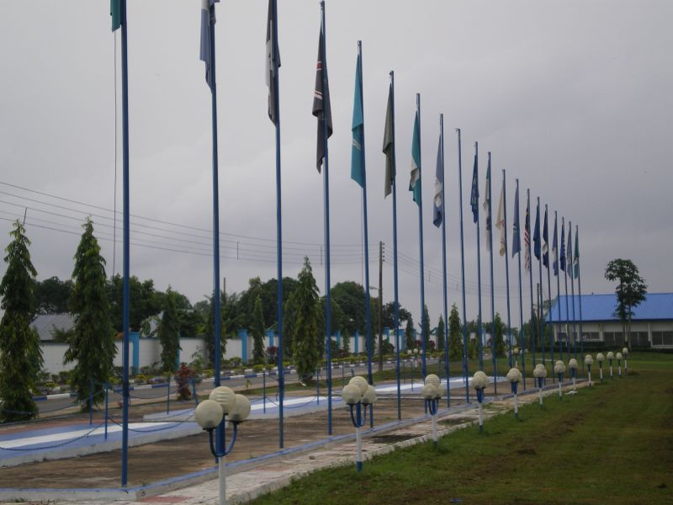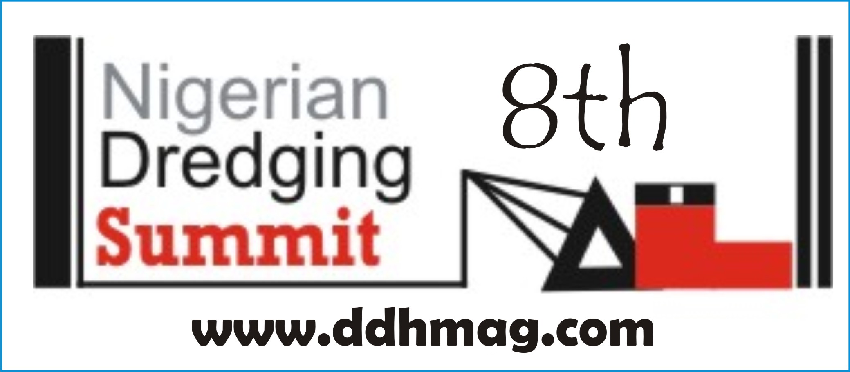

8TH NIGERIAN DREDGING SUMMIT AND EXHIBITION, UYO 2014.
With SEMINARS & EXCURSIONS to TOURIST ATTRACTIONS.

INVITATION TO NOMINATE DELEGATES.
THEME: ENVIRONMENT-FRIENDLY DREDGING AND NEW PORT DEVELOPMENTS.
You are hereby invited to nominate delegates to the 8th edition of the Nigerian Dredging Summit and Exhibition which will take place as follows:
Date: Wednesday to Friday, September 17th to 19th, 2014.
Venue: Entry Point Hotel, Uyo, Akwa Ibom State.
Time: 9:00am.
Brief Introduction
The annual Nigerian dredging summit offers a healthy interactive forum for operators and stakeholders from within and outside Nigeria to meet and share ideas and presentations on the burning issues in the industry. It has also proven to be a marketplace for operators and vendors who visit the exhibition stands and interact with one another.

Dredging activities are fast assuming a commanding height in the Nigerian economy. From the increasing demand for all grades of sand for building private houses, road construction and for reclaiming swampy land, dredging is also at the centre of most shore-based and shallow-water oilfield projects in Nigeria. Nigerian operators are now in need of the right training, orientation or re-orientation for providing adequate products and services for these sectors.

Year by year, we see an increase in the number and variety of participants. They include Nigerian and foreign dredging companies, equipment manufacturers, suppliers and vendors, federal and state government ministries and regulatory agencies such as Ministry of Mines and Steel, Ministry of Environment, Ministry of Petroleum, Ministry of Transport, NNPC, NPA, NIMASA, NCDMB, LCM, BCC, Ministry of Works, Ministry of Water Resources, etc.
The theme of this year’s event is Environment-Friendly Dredging and New Port Developments. Most of the papers are being packaged to address the overwhelming concern to main sound environmental practices in sand mining, land reclamation and harbor dredging activities. There is the concept of green ports which is an affirmation of the need to constantly maintain balance in the ecosystem.
EXCURSION
In line with our standard practice, delegates shall be conveyed, in air-conditioned buses, to places of tourist attraction within the locality, usually, on the second day of the summit and exhibition. This package, which includes lunch-on-the-go, comes as part of the participation fee and does not require any extra payment. Delegates are advised to come with running shoes or sneakers to better enjoy the experience. T-shirts and caps will also be freely supplied.

LEADING PAPERS AND PRESENTATIONS AT THE SUMMIT:
- “EIA Regimes for Environmentally-Safe Dredging and Related Projects” by Federal Ministry of Environment.
- “Opportunities for Dredging and Sand Mining in Various States in Nigeria” by State Governments.
- Buying or Leasing a Dredger – Options for Importation or Building in-country. By Engr Hector, etc.
- Training Options for Dredging and Marine Skills. University of Uyo (Capt. Ntiandem)
- Financing Dredge Sector Equipment and Leasing in Nigeria by a Bank. Fidelity Bank?
- Challenges of Megacity Drainage Systems for Lagos. Min of Environment, Lagos.
- “The Future of Ports in Nigeria: Deep Sea Port Developments” by NPA.
- “Channel Management Joint Ventures: Celebrating The Prospects, Managing the Challenges” by LCM.
- “Capital and Maintenance Dredging along the Bonny Waterway” by BCC.
- “The National Framework for Intermodal Transportation” by Federal Ministry of Transport.
- “Dredge and Equipment Repairs, Maintenance and Inspection” by Dave Moore.
- “Implementing Cabotage Law for Dredging Activities: Deepening NIMASA’s Role in Harbour Dredging and Sand Mining.”
- Pre-Dredge Surveys and Proofing Sand Search Reports. By Osanebi Felix.

EXHIBITION STANDS /MARKETING
As usual, the organizers encourage equipment vendors and other service providers to show off their wares or services on the sidelines of the dredging summit. Organizations that are interested in taking up Exhibition spaces should contact the organizers as soon as possible via email or telephone. See the section on participation fees below for costs and size of booths.
REASONS FOR THE SUMMIT AND EXHIBITION
- Dredging activities are now becoming a solution of choice for many projects of the federal, state and local governments. It has always served the needs of oil field operating companies. It is also now becoming useful for private sector real estate development through the demand for sand. Since the 1960s and even before then, the need for capital and maintenance dredging for harbors have kept many dredging firms constantly busy. In recent times, many startup Nigerian firms have joined the ranks of foreign dredging contractors, so that dredging in Nigeria today has come to stay and is now widening in scope.
- To nurture the growing Nigerian industry, there is an increasing need for best practices to be instituted as a guide for all stakeholders. Especially for new entrants into the sector, there is the need for dissemination of adequate knowledge and information about rules and regulations and technical know-how to improve the industry from time to time.
- The Nigerian Dredging Summit is also a marketing arena, a meeting place for dredging and dredge equipment makers and vendors as well as a place for interaction between environmental engineers, consultants, academics and governmental regulatory agencies for the exchange of ideas and meaningful debates of existing policies.
- The summit provides another forum of a meeting for umbrella associations in the dredging sector.

BENEFITS OF ATTENDING…

- Local and international exposure for participants.
- For some attendants, it is an opportunity to visit new places and locations they only read about in the mass media.
- Up to 10 or more staff of each participating organization can be accommodated to experience the interaction, exposure and training that comes with the event.
- Staff morale is usually boosted by involving them in this event and they return to their desks more motivated and enlightened to deliver quality service and performance at their jobs.
- Each participating organization will have the option of addressing the delegates on the various statutory mandates of their establishments and new developments and thus promote the implementation of government or company policies needed to achieve governmental budgetary or corporate aspirations. Companies get an opportunity for sales talk via Powerpoint presentations.
- Board members of participating agencies or organizations may attend to keep abreast of relevant issues.
- Interaction with professionals in the dredging sector yields future collaboration and networking between public and private sector operators in various areas of the economy.

PARTICIPATION FEES.
REGISTRATION FEES:
Individual Delegate (1 person) N100,000.00
Group Delegates, 3 participants N260,000.00
Group Delegates, 4 participants N340,000.00
Group Delegates, 5 participants N400,000.00
CORPORATE PARTICIPATION PACKAGES
OPTION A:
- 12 or more delegates.
- A Stand at the Exhibition Hall for interactions with participants interested in your organization.
- Display of podium or hallway banner adverts at the venue.
- 1 full-page colour advert or public notice of the organization in the Nigerian Dredging Summit Brochure.
- 1 full page of the Dredging Summit Brochure devoted to a corporate profile of the organization with pictures of their management staff.
- To be listed as an official sponsor in any radio, television or print advert of the Summit prior to the event.
COST - N6m
Option B
- 8 Delegates.
- A Stand at the Exhibition Hall for interactions with participants interested in your organization.
- Display of a hallway banner advert at the venue.
- 1 half-page colour advert or public notice of the organization in the Nigerian Dredging Summit Brochure.
- 1 half-page of the Dredging Summit Brochure devoted to a corporate profile of the organization with pictures of their management staff.
- To be listed as an official sponsor in any radio, television or print advert of the Summit prior to the event.
COST - N4.5m.
Option C
- 6 Delegates.
- A Stand at the Exhibition Hall for interactions with participants interested in your organization.
- Display of a hallway banner advert at the venue.
- 1 quarter-page colour advert or public notice of the organization in the Nigerian Dredging Summit Brochure.
- 1 quarter-page of the Dredging Summit Brochure devoted to a corporate profile of the organization with pictures of their management staff.
- To be listed as an official sponsor in any radio, television or print advert of the Summit prior to the event.
COST – N3m .
Option D
- 3 Delegates.
- 1 quarter-page Black-and-White advert or public notice of the organization in the Nigerian Dredging Summit Brochure.
- To be listed as an official sponsor in any radio, television or print advert of the Summit prior to the event.
COST – N1.5m
SUMMIT COLOUR BROCHURE
A Summit Colour Brochure where adverts can be placed is usually published for the Event with the following advert rates.
Advertisement rates for the Colour Brochure:
Outside Back Cover N250,000.00
Inside Front Page N200,000.00
Inside Back Cover N180,000.00
Full page N150,000.00
Half Page N95,000.00
MODE OF PAYMENT
Two modes of payment are acceptable.
- By cheque, made payable to: DREDGE SKILLS AND MARINE TRAINING CENTRE LTD.

- Or by bank transfer / E-Payment to our bank accounts as follows:

Name of Bank: Stanbic IBTC Bank Plc.
Name of Account: Dredge Skills And Marine Training Centre Ltd.
Account Number: 9202145879.
Sort Code: 221150690.
Email Address: dredgeskills@gmail.com
Telephone: 08033378735.
Name of Bank: GT Bank Plc, Ajah Branch.
Name of Account: Dredge Skills And Marine Training Centre Ltd.
Account Number: 0013355857.
Sort Code: 058152272.
Email Address: dredgeskills@gmail.com
Telephone: 08033378735.
To request payment invoices, please contact the secretariat by email or phone.
CONTACT DETAILS
DREDGE SKILLS AND MARINE TRAINING CENTRE LTD,
E270 Ikota Shopping Complex,
VGC AJAH.
LAGOS.
TELEPHONE: +234 1 7928166 or 08033378735.
EMAIL: dredgeskills@gmail.com
WEBSITE: www.ddhmag.com

