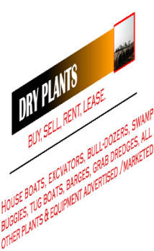
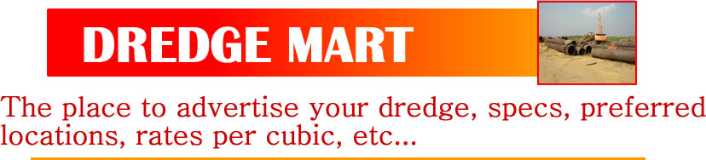

DREDGE MARKETING / ADVERTISING / PROMOTION FORM.
We constantly get inquiries from people desiring to rent or lease dredgers, dry plants and other field operations equipment. As publishers of dredging industry information, we have created an online marketplace where you can market your dredge and dredging services, tools, equipment and paraphernalia. It’s on our website, www.ddhmag.com (DREDGE, DRILL & HAUL / AFRICAN PLANTS AND EQUIPMENT DIGEST). The colour pictures and specs of the equipment are advertised in boxes on this website.
To advertise your dredge or other property, please fill out this form and return to us by email or to our office at:
Block E, Shop 187, Ikota Shopping Complex, VGC, Ajah. Lekki Lagos, Nigeria. (+234 1 7928166 / 08033378735).
Email: dredgeskills@gmail.com
Equipment to be advertised can include:
- DREDGES, * DRY PLANTS, *HOUSE BOATS, *EXCAVATORS, *BULL-DOZERS, *SWAMP BUGGIES, *TUG BOATS, *BARGES, *GRAB DREDGES. *ANY OTHER PLANTS AND EQUIPMENT.
S/No. | EQUIPMENT: DREDGE OR DRY PLANT | SPECIFICATIONS | LOCATION YOU DESIRE TO WORK | CONTACT PERSON / EMAIL AND PHONE NUMBER.
You may use extra sheet of paper if you need more space. Upload pictures as email attachments (JPEG, PNG, PDF formats).
REGISTRATION FEE FOR THIS SERVICE IS N5,000.00 . ADVERT SPACES ARE N10,000.00 per month. Freely contact us if you need more details, please.

