BENEFITS OF DREDGING TO INLAND WATERWAYS MANAGEMENT AND NATIONAL DEVELOPMENT

Prof. P. C. Nwilo¹ (pcnwilo@yahoo.com), Q. A. Adejare² (quadriadejare@yahoo.com) and **Y. D. Opaluwa² (geopaldy_xy@yahoo.com)
¹Department of Surveying & Geoinformatics, University of Lagos, Nigeria.
²Department of Surveying & Geoinformatics, Federal University of Technology, Minna, Nigeria.

- INTRODUCTION
Waterways have always provided an avenue for transportation, communication, agricultural development and trade. Great civilisations revolved around important rivers. The city of Alexandria in Egypt grew because of its location at the mouth of the River Nile and served as a major centre of civilisation and trade. In Nigeria the towns of Lagos, Port Harcourt, Warri, Calabar, Onitsha, and Lokoja all developed due to their locations on the banks of rivers and waterways. Historically these cities served as avenues for the Europeans to carry out trade and communication with the hinterland. They also played important roles during the period of slave trade (Nwilo, 2002).

The River Niger is structurally controlled as it flows in a valley bounded by linear faults trending NW to SE from its entry into Nigeria up to its confluence with the Benue at Lokoja. From Lokoja down to the Atlantic Coast the river runs in a North-South direction carrying with it, large volumes of sediments which are deposited in the coastal plains. The River Niger has its source in the Foutadjalon Mountain in Guinea, and flows into the Gulf of Benin in Nigeria after a course of 4100km. the drainage basin of the Niger covers an area of 1,110,000km² (Sennuga, 2002).
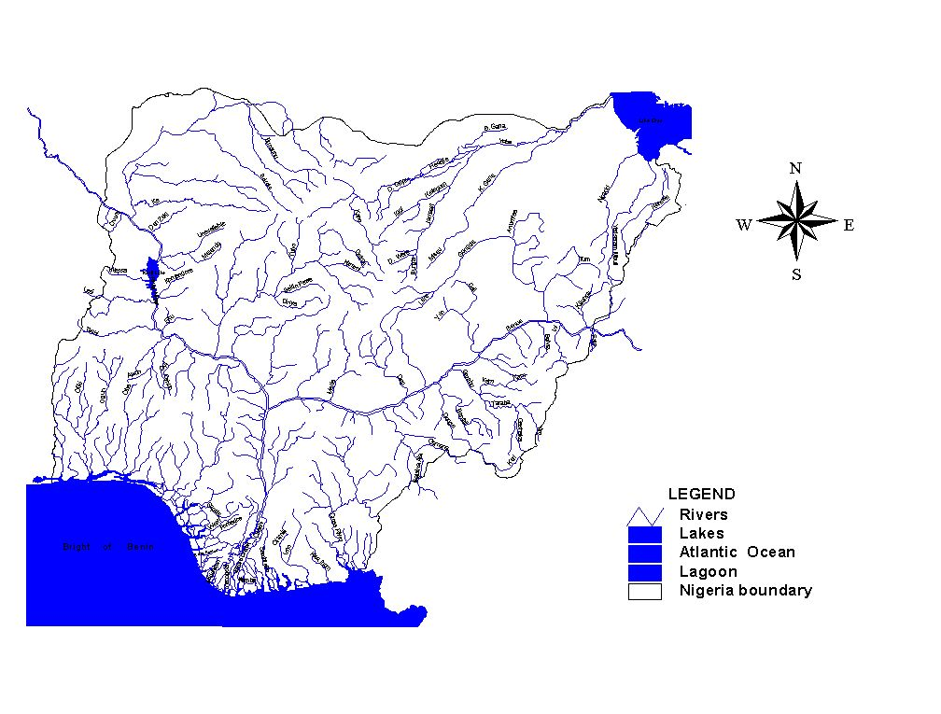
Figure 1: Major rivers in Nigeria (Source: Nwilo, 2002)
The transportation activities in the waterways are very low. The traffic on the River Niger can be increased significantly. As the road network reaches its economical and ecological limits, a shift of transportation to inland waterways will make the situation easier. Another positive effect of this possible shift is that Carbon IV Oxide (CO₂) emissions will be cut down significantly (Kuhtreiber, 2007). A river information service is a concept for harmonized information services to support traffic and transport management in inland waterway navigation including interfaces to other transport modes.
Each vessel needs to be equipped either with a fixed or a removable transponder. Additional transponders are installed ashore to provide local and government authorities with an actual traffic image, while positioning technologies to be used for traffic management systems on inland waterways have to fulfil different requirements with regards accuracy, availability, integrity and actuality. Hence Differential Global Positioning System (DGPS) receivers will be used on local reference stations along the river for monitoring.
Inland waterways transportation is a key component of the intermodal transportation network and is essential to Nigeria’s economy, environment and quality of life. The nation’s transportation system and taxpayers would benefit from the completion of essential navigation infrastructure and the containment of cost overruns.
Inland water transportation system (IWTS) offers an economic and eco-friendly mode of transport, particularly for the movement of bulk cargo and passengers. Inland waterways have remained the most neglected segment of Nigerian transportation system. Colin (1998) asserted that travel by water predates the wheel and remains a vital form of transport for millions of people in rural and urban areas. Though inland water transport (IWT) is comparatively a cheaper and efficient means of transportation, in the nearest future, the utilisation of this mode of transport shall be enhanced by the successful completion of the on-going dredging of the river Niger from Baro in Niger state to Warri in Delta State.
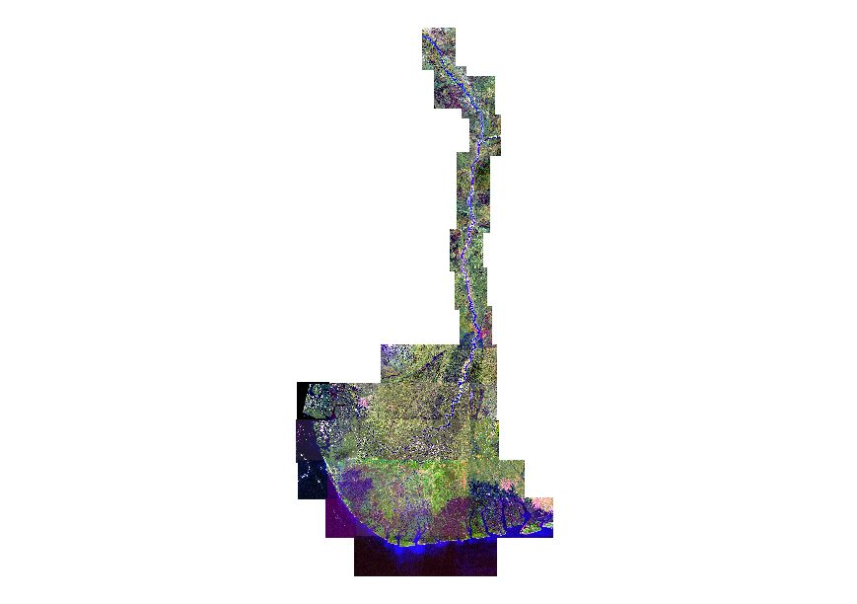
Figure 2: Spot Image of the Lower River Niger From Baro To The Niger Delta (Aerospace Geomatics Ltd, 2002)

IWT has a significant part to play in the states of Niger, Kogi, Anambra Delta, Bayelsa, Rivers, Akwa-Ibom, Benue, Adamawa, Cross River and Lagos. The waterways in these states connect several minor ports/jettys and the major port of Baro, Lokoja, Onitsha, Warri and Apapa as well as the host of industries located along the river. The inland waterways and their corridors should be developed in an intergrated broad-based way, conserving where possible their environment and protecting their unique ecological systems, to enhance sustainable use of the inland water for now and for future generations. The IWT strategy aims at generating a more pro-active role by the different government agencies for the development of this sub sector. The Government’s revival plan for IWT includes increasing the coverage of National waterways.

Under the current development plan, the Federal Government plans to extend the National Waterway System by declaring the on-going dredging of River Niger and all other tributaries along the River Niger corridors. The reasons for taking up this developmental programme is to develop the IWT in the River-rine states where it enjoys natural advantage, modernization of vessels and country crafts to suit local conditions and improvement in the productivity of assets. The Lagos State Government is also laying a lot of emphasis on the development of her waterways. The State recently carried out a comprehensive Bathymetry of her waterways

The waterways are the cheapest mode of transport. According to a recent study conducted by National Council for Applied Economic Research (NCAER), the per-t-km cost of transportation by inland waterways is Rs 0.55, compared to Rs 1 by road. For the movement of bulk cargo, inland waterways are considered more fuel-efficient than any other mode. Yet today this potential remains highly unexploited. The development of motorable roads, particularly national highways, and the introduction of large trucks, has left the country’s waterways behind. The motorboats and the passenger vessels that replaced the country boats were hit by infrastructure deficiencies (Misra, 2007).

- CURRENT SITUATION IMPAIRING USE OF WATERWAYS
2.1 Construction of Dams along the Waterways
Dams have been constructed across the rivers and their tributaries for generation of electricity, irrigation and supply of drinking water to the population. Three major dams meant for electricity and irrigation was constructed in Nigeria across the River Niger and its tributary. These include Kaduna River at Kanji, Jebba and Shiroro. The construction of these dams has certainly affected the volume of water available for navigation on the rivers. It also affects the volume of sediments on the River Niger. There are other dams along the tributaries of the Niger and Benue. These dams are essentially for agricultural purposes and sources of drinking water to the population. Figure 3 shows some of the dams along the rivers in Nigeria.
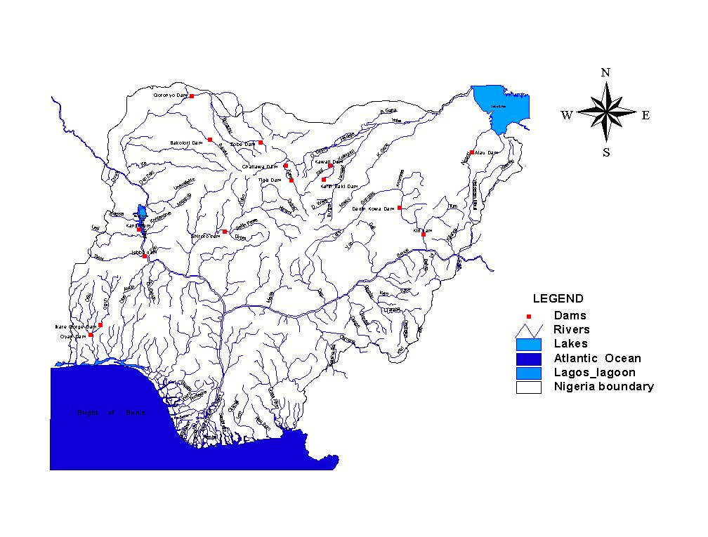
Figure 3: Some of the dams in Nigeria

2.2 Sedimentation Due to Some Natural and Human Factors
A number of factors are known to affect the course of the River Niger and Benue particularly in the areas that are not within the rock formation. A comparative analysis of aerial photographs and topographic surveys of the Lower Niger show that the River continues to widen over time due to riverbank erosion. Apart from river bank erosion, which brings in a lot of sediments, agricultural activities in the hinterlands, urbanisation and land erosion also contribute to sediment action. These activities affect the course of the rivers and consequently impede navigation (Nwilo, 2002).
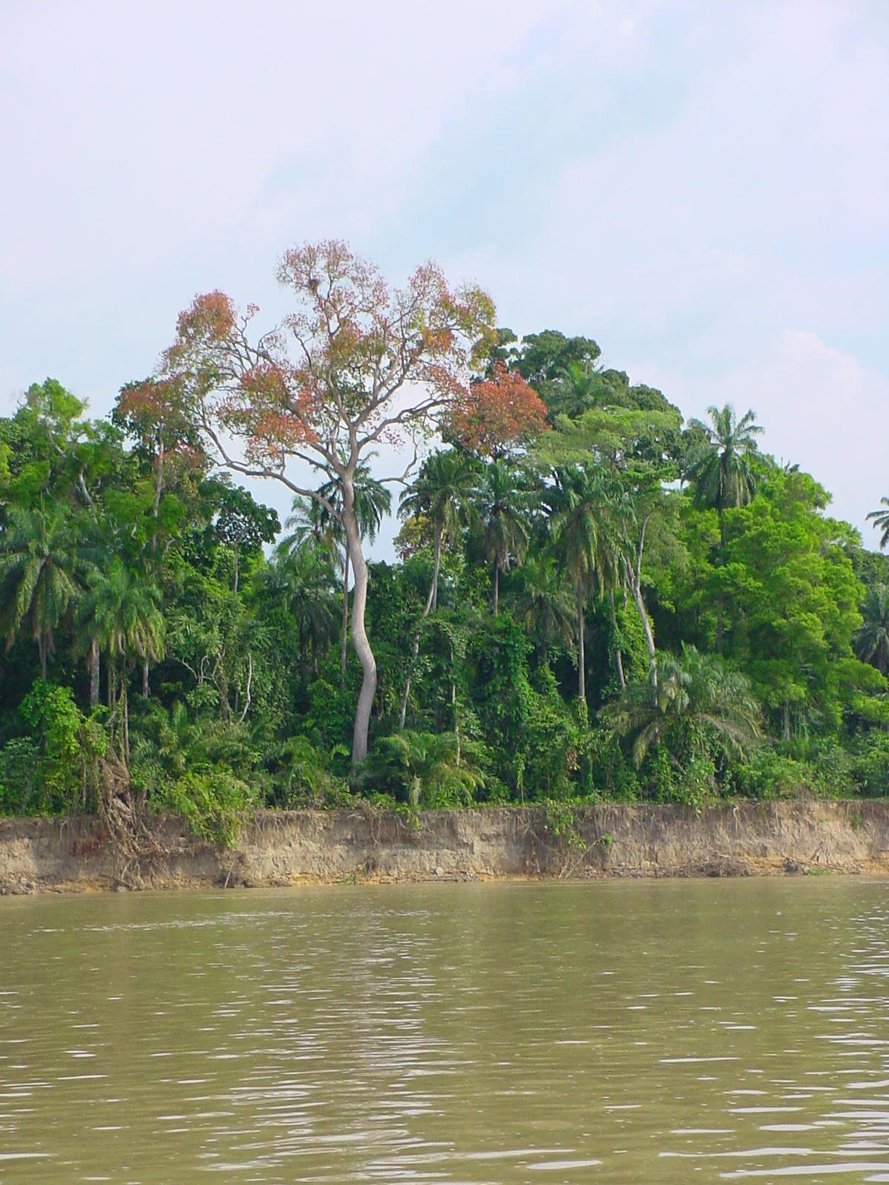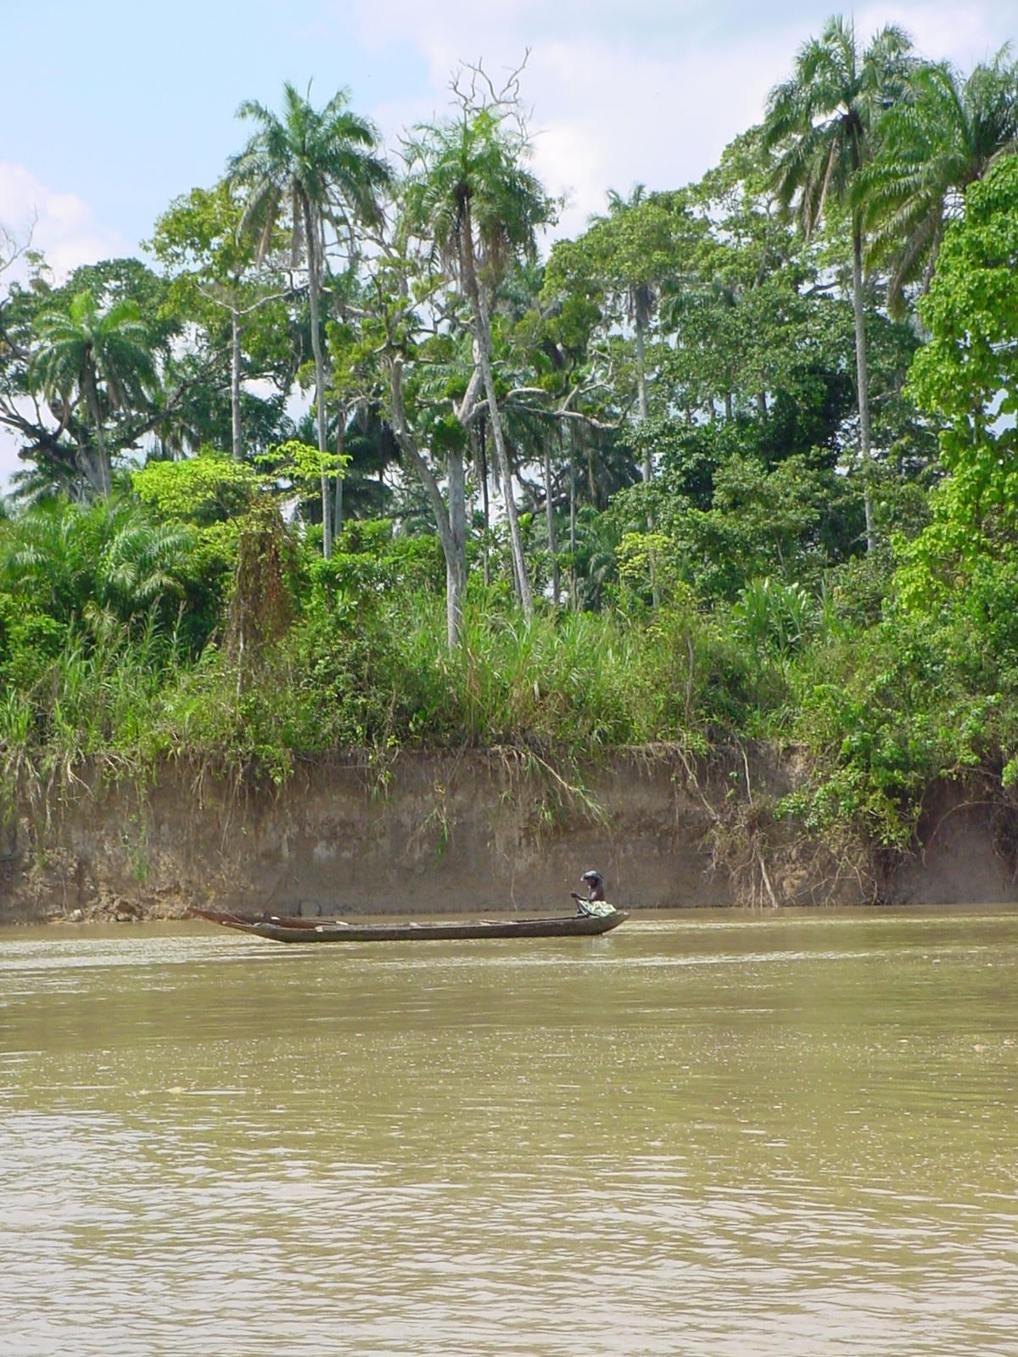

Figure 4: Cases of River Bank erosion along the Lower River Niger

Lacks of capital and recurrent dredging to clear blockages along the course of the rivers have also led to changes in the courses of the rivers. It is not very certain to what extent urbanisation, increased population, agricultural activities, land erosion and dam constructions have affected the sediment load in the rivers. It is however certain that construction of dams leads to reduction in sediment load while the other factors lead to its increase.
Therefore, the major issues impairing the growth of Nigerian waterways could basically be summarised as follows:
- The share of cargo currently is very small as compared to coastal trade.
- There are serious navigable constraints owing to sedimentation and river courses.
- There are not enough vessels and operators for such routes.
- There is serious lack of storage facility around the waterways.
- Environmental and social protections are the key factors that need to be addressed in the waterways.
- There are serious concerns of institutional set up along the waterways.
- Private sector participation in the developmental plans is still not forthcoming.
- Cargo operator transit arrangement has not yet been standardized.
- Investment loans are not forthcoming.
- Integrated development is not a visionary thrust area.

2.1 Benefits of Using Waterways
As compared to road and railways, the waterways are important means of transportation; to accelerate the economic growth in the following manner:
- It can be a supporting role for road and rail transport.
- It is far more cost effective per kilometre of travel.
- It is highly efficient in energy consumption per tonne load carried.
- Load capacity can be doubled by small increase in depths by dredging.
- Considerable flexibility in ageing transportation and cost elasticity.
- Inherently low human cost.
- Reduce sediment problem along the River Niger.
- The deposition of material from dredging can be viewed simply as a relocation of material rather than an input of new pollutants.
- Sediment can be useful for soil amendment and landscaping.
- Managing pollution in the Aquatic system through the prevention of pollution and remediation techniques. However, the remediation could be achieved in any of the following: Speciation/ separation, destroying the organisms by incineration, soil washing, solidification, Phytoremediation, Bioremediation.
Considering the above, it becomes quiet apparent that ensuring a green and consistent waterways would be most meaningful for the national level.

3.0 DREDGING
Dredging is an excavation activity or operation usually carried out at least partly underwater, in shallow seas or fresh water areas with the purpose of gathering up bottom sediments and disposing them at a different location. In actual sense, dredge is a device for scraping or sucking the riverbed / seabed, used for dredging and dredger is a ship or boat equipped with a dredge. In technical usage, any floating vessel equipped with dredging equipment is called a dredger (Misra, 2007).

3.1 Types of Dredgers and their Relevance to Waterways Development
There are several types of dredging which are carried out in waterways to ensure that the waterways are kept clear and navigable. The common types of dredgers are:
- Clearing and snagging dredgers which are used to track log jams, clear debris, sunken vessel, etc.
- Mechanical and hydraulic dredgers which are principally used to clear riverbeds, ponds, estuaries, interlinks between rivers. Most waterways have soft soil except for parts where there is a rocky bed. There are other types of dredgers, namely: Dust pan dredger. Side cost dredger which are used to remove loose compacted course grained material at a rapid pace. Dredgers can also be amphibious and are usually portable.
Without regular dredging operations as is the case in most part of the world, the world’s commerce would have been impaired because bulk of the goods travel by ship and need to access harbours or seas via channels. In addition, recreational boating also would have been constrained to the smallest vessels. The majority of marine dredging operations (and the disposal of the dredged material) will require that appropriate licences are obtained from the relevant regulatory authorities and dredging is usually carried out by harbour companies or corresponding government agencies.

3.1.1 Why Dredging?
Main reasons for dredging include:
- Increasing / maintaining the depth of water in a navigation channel.
- Spot excavations preparatory to major waterfront construction like, bridges, piers, or dock foundations
- Harvesting sand for usage in concrete production or for beach restoration
- Waterways management and maintenance for flood and erosion control.
- The process of dredging creates spoils which are conveyed to location different from the dredged area; dredging can create disturbance to aquatic ecosystems, often with adverse impacts. On the other hand, dredging can produce materials for land reclamation or other purposes (usually construction related). Dredging has also historically played a significant role in socioeconomic development and upliftment.
3.2 Characterisation of Dredged Material
An evaluation of the physical, chemical and biological characteristics of the sediment is necessary to determine: potential dredging methods; use, disposal or treatment options; potential impacts; extent of biological and/or chemical testing; and monitoring needs.
Sediments are natural elements in any river basin as well as the seabed. Although dredging interferes with the natural cycle of sedimentation and re-suspension, nowadays the environmental focus has shifted towards a “river basin approach”, i.e taking into account all activities in a total view. It shifts the scope from the management of dredged material to complete river basin sediment management. It integrates the economic need for dredging, the beneficial use of the material, and the reduction of the effects of dredging and disposal, as well as source control.

3.2.1 Beneficial Uses of Dredged Material
Dredged material is no longer being regarded as a ‘spoil’ or ‘waste’ but as a resource. Beneficial use of dredged material may be defined as the placement or use of dredged material for some productive purpose. Its mineralogy and geotechnical properties qualify it for use in the manufacture of high value, beneficial use products. Dredged material may be used in a variety of beneficial use applications. A listing of these include ocean remediation, upland restoration, filling degraded basins and pits, creating and restoring wetlands for water quality treatment and habitat and creation/restoration of other habitats, such as, oyster reefs and bird habitat. Beneficial use end products include topsoil, construction grade cement, lightweight aggregate, bricks and architectural tile. Often, these beneficial uses can come at a cost- saving to the public. All dredged material proposed for beneficial use will be evaluated in a framework which protects human health and the environment. Most dredged material can be a valuable resource and should be considered for beneficial uses.
Most dredged material is clean sediment. It should be recognised as a resource, as part of the ecological system. Options for beneficial use are numerous: they vary from coastal nourishment, land or wetland creation, and soil improvement to dike building and use as construction material. Dredged material should be used, whenever possible, to maximise the benefit to both the project and the beneficial user.

3.3 The Benefits of Dredging
Anticipated derivable benefits from the dredging of the Niger Water system would among others, include the following:
- Improved transportation system through increased navigational channel for the movement of bulk cargoes. This would lead to the realization of the National Transport Policy and mass transit objectives of the country.

- Economic viability resulting from reduction in the cost of transportation.

- Availability and affordability of transportation services. Presently the volume of cargo is expected to double as a result of the dredging.

- The Niger-Benue water system links Nigeria to Niger, Upper Volta, Chad and Cameroon. It is therefore of strategic economic importance to the Economic Community of West Africa States (ECOWAS).

- Improved communication link between the coast and hinterland in Nigeria.

- Job opportunities along the riverine and inland areas arising from the dredging project.

- The dredging will provide auxiliary benefits to the host communities in the area through the development of fish ponds at designated locations, as a mitigating measure to disruptions in fishing activities that may be suffered by fishermen.

- Dredge spoils will be used to fill up marshy areas if requested by communities. This would result in increase in habitable and agriculturally productive land mass available to the host communities.

- Decongestion of sea/coastal ports thus eliminating bureaucratic bottlenecks at ports. This would lead to improvement in international trade.

- Improved interaction between peoples and cultures of the lower Niger Delta, which would lead to better understanding and tolerance.

- Improved quality of life from the numerous economic activities that would be generated along the riverbanks. This would lead to a high level of economic self-sufficiency within the host communities (Triple “E”/Global Joint venture, 2001).

- It would minimise problems of environmental pollution arising from emission of greenhouse gases and noise from people and vehicles;
- Diversion of traffic to waterways would in turn provide relief to roads and consequently improved lifespan of roads.
- It will lead to bulk transportation of goods thereby reducing the cost of these goods. (Not for ocean vessels carrying large cargoes).

3.4 Strategies for Sustainable Management of Waterways for National Development
To ensure that the National waterways get the proper thrust, certain measures need to be taken at the national level which would be in the following lines:
- Raise tax-free point and mobilize fees for infrastructure development.
- Encourage commercial/joint venture and provide for grants and subsidies.
- Encourage private sector participation.
- Introduce phased tax exemption.
- Enhance depreciation rate of vessels.
- Introduce vessel-building subsidy for Waterways.
- Minimize the custom duty
Other strategies that could enhance sustainable management of the waterways therefore include:

3.4.1 Phased Development
In order to ensure that the waterways get the right projection, the development should be done in phases and integrated development of waterways needs to define the human parameters for infrastructure requirement, dredging, navigation equipment, terminal, etc and every day requirement along with operational matters. Once this step is concluded, then the next step of development would be to define Strategic marketing plan, project master plan, preliminary engineering for infrastructure, channels, navigation, terminals, storage, etc.

3.4.2 Organisational Management
This is cardinal to the realisation of the goals of this scheme and the major components of this strategy are:
(a) Monitoring and advising on River Niger corridors issues including both the man-made and natural aspects;
(b) Realising the potential for understanding and enjoyment of all aspects of built and natural infrastructure along the waterways through education and promotion;
(c) Realising the socio-economic benefits of developing the inland waterways, using conflict management between conservation of the River Niger corridors and usage of the waterways and between users and development pressures;
(d) The strong central control of all aspects of waterways management. In order to fulfil these functions adequate professional staff would be required in the following areas:
- Strategic planning
- Navigation & Engineering
- Planning & Development
- Natural & Built Heritage
- Education, Promotion, and Marketing

3.4.3 Resource Management
The current situation of a multiplicity of government departments and other agencies involved with various aspects of management of the waterways has led to a lack of cohesion. Therefore, in order to enhance uniform co-ordination and efficient resource management, Water quality enforcement and monitoring should continue to be carried out by the local authorities and other agencies which have a statutory obligation to do so. Those of the Kanji Dam in supply of Hydro Electric Power Generation should be preserved.

3.4.4 Development Control and User Management
Where development, industrial or recreational projects could impact negatively on the waterway corridors, Areas of Special Control should be identified in consultation with local authorities and users included in their state development plans. The infrastructure of the inland waterways system needs to be improved in partnership with the local authorities, local communities and the private sector.
Recognition of the wider socio-economic benefits derived from waterway projects must be considered in development plans for urban waterways to ensure the maximum advantage for the areas involved. Waterways can be used as a catalyst for development. All developments in waterway corridors including tourism-related projects should take into account potential adverse effects on the heritage of the waterways. Policies and guidelines are needed to ensure sustainable developments on the waterway corridors. The voluntary sector should be encouraged to continue its involvement in waterways development and non-governmental organisations should be recognised as important.
For national coordination in the use of water resources, inland waterways is an integral component of the overall transport system of the coastal state and is one of the most advantageous transport modes, having the least impact on the environment, the lowest cost for domestic and international transport, enormous capacity reserves and the least energy consumption. The potential of inland water transport for encouraging and supporting increased economic and social development in rural areas is enormous.

3.4.5 Balance Economy and Ecology
The overall management goal should be to achieve a sustainable solution, subject to sound environmental, social and financial impact evaluations, weighing and balancing all the associated risks. Identifying and involving all potential stakeholders and affected parties from the conceptual stage onwards through to the completion of the project is essential. Communicating clearly and competently on the physical, environmental, social and financial effects of a project should always be regarded a key success factor. The dredging community is often able to remediate contaminated sediments. Even when this is possible, a high priority should always be given to source control. Successful implementation of prevention strategies will require collaboration amongst all players from source to sink.

3.4.6 The Need for Sustainable Relocation
Marine or fluvial sediments normally contribute to the sustainability of natural ecosystems. Their role in river, estuarine and coastal zone processes should be respected wherever possible. Removing marginally contaminated sediment from an ecosystem may actually, in specific cases, be more detrimental than relocating it. Consequently, an environmental impact analysis is crucial, especially when considering sustainable river and coastal management. Environmental impact assessment is an important pre-requisite to dredging initiatives. Such an assessment is used to establish and, where necessary, to explore options to mitigate possible effects of dredging or disposal on the physical environment, wildlife, habitats, fisheries, archaeology and many other interests

3.4.7 Environmental Impacts
Dredging can create disturbance to aquatic ecosystems, often with adverse impacts. In addition, dredge spoils may contain toxic chemicals that may have an adverse effect on the disposal area; furthermore, the process of dredging often dislodges chemicals residing in benthic substrates and injects them into the water column. The activity of dredging can create the following principal impacts on the environment:
- Release of toxic chemicals (including heavy metals and PCB) from bottom sediments into the water column;
- Short term increases in turbidity, which can affect aquatic species metabolism and interfere with spawning;
- Secondary effects from water column contamination of uptake of heavy metals, DDT and other persistent organic toxins, via food chain uptake and subsequent concentrations of these toxins in higher organisms including humans;
- Secondary impacts to marsh productivity from sedimentation;
- Tertiary impacts to avafauna which may prey upon contaminated aquatic organisms;
- Secondary impacts to aquatic and benthic organisms’ metabolism and mortality; and
- Possible contamination of dredge spoils sites.

4.0 CONCLUSION AND RECOMMENDATIONS
4.1 Conclusion
Considering that the waterways are an important means of movement of cargo and passengers and the essentials of dredging being a tool to enhance the activities on the waterways, it is pertinent to now evolve a policy which goes beyond just moving cargo and passengers over distances. It is essential to rely on the need for all round development of the socio-economic fabric of an entire region near the waterways so that it can sustain the development and economic growth of the people dependent on these waterways.
It is also important to understand that in creating a channel or navigable route, a number of other issues connected to environmental, eco-system, livelihood, flourochlorine also come up.
The development of Inland waterways would certainly depend upon making the best use of all resources. In addition many of these waterways are now being revived and the economic growth along these waterways is fuelling enhanced social status. However, intelligent dredging and its management can bring about vast changes in the transportation system as well as the related growth factors. One of the most under utilized and unexplored tools of modern growth needs to be given that thrust to enable it to turn around the local economy. From the foregoing submissions, the fact that there are vast opportunities in dredging which are appropriate and relevant to the sustainable management of waterways and National development cannot be over emphasized.

4.1 Recommendations
We therefore, recommend that it is important to:
(1) Integrate inland water transport within intermodal transport systems to provide door-to-door services for the movement of domestic and international traffic, thereby responding to market demand for convenient and competitive service while optimizing the economic, financial, environmental and social benefits that can be derived from each mode in the entire transport chain;
(2) Undertake detailed examination of the technical and administrative issues related to bringing national waterways into operation with the objective of facilitating passenger traffic;
(3) Facilitate passage traffic, financial, social and environmental benefits, and to promote public awareness of such benefits, it will encourage a modal shift to inland water transport where appropriate;
(4) Enhance cooperation between agencies responsible for inland waterways and water resources management for navigation purposes through coordinated national planning and development and implementation of policies;
(5) Increase the public and private sector resources allocated to inland water transport to reflect the relative priority of such transport and to encourage partnerships between the public and private sectors to improve the development, management and operation of inland water transport;
(6) Furthermore, there is need to also encourage:
- The adoption of appropriate legislation and the creation of a regulatory environment for the protection and effective utilization of inland waterways;
- Facilitation of cargo trans-shipment between seagoing ships and inland vessels for onward distribution;
- The recognition and strengthening of the role in socio-economic development of the country boats and small vessels operated by the informal sector, with particular reference to poverty alleviation in rural areas;
- The utilization of dredged materials, wherever economically advantageous and socially and environmentally acceptable, to raise and revitalize farmland, strengthen bank protection and reclaim land;
- Development of tourism along inland waterways;
(7) To establish or strengthen appropriate centres and institutional capacity to undertake studies and research to identify physical and institutional bottlenecks that are hindering the efficient development and operation of inland waterway, and to promote human resources development to address those deficiencies;
(8) To promote technological advancement of the inland waterways sector through the provision of technical assistance.
(9) Relevant other governments and agencies to support projects that promote the integration of inland water transport within intermodal transport systems and its integration into comprehensive planning for water resources management.

Reference:
Sennuga, A. A. (2002): Sediment and sediment problems within the national inland waterways authority (NIWA) operation areas. Proceedings of the expert group meeting on pollution and sediment sources in the Nigerian inland waterways and strategies for their management (Lokoja, 23-24 October).
Colin, P. (1998): Water Transportation for Rural Settlements.
Kuhtreiber, N.; Jandrisits, M.; Pfliegl, R. and Hofmann-Wellenhof, B. (2007): Value-added serices for river information systems. Vermessung &Geoinformation 2/2007, P. 186-194, 8 Figs July 2-13,2007, Perugia, Italy
Misra, P (2007): Dredging and integrated development of inland waterways. Paper presented at the twentieth national convention of marine engineers held at visakhapatnam, February 24-25.
Aerospace Geomatics Ltd (2002): Project Report on the Mapping of the Lower River Niger at a scale of 1/50,000.

Nwilo, P. C. (2002): Navigation on the Lower River Niger and the Nigerian Inland Waterways Development Master plan.
Triple “E”/ Global Joint ventures (2001): Environmental Impact Assessment Report on the Proposed Dredging of the Lower Niger Waterway.

